**Wire-Frame Design**

**THYROID DISEASE PREDICTION**

|  |  |
| --- | --- |
| Written By | Ganesh Sayaji Thorat |
| Document Version | 1.0 |
| Last Revised Date | 20-01-2022 |

**Document Change Control Record:**

|  |  |  |  |
| --- | --- | --- | --- |
| **Version** | **Date** | **Author** | **Comments** |
|  |  |  |  |
|  |  |  |  |
|  |  |  |  |
|  |  |  |  |
|  |  |  |  |
|  |  |  |  |
|  |  |  |  |
|  |  |  |  |
|  |  |  |  |
|  |  |  |  |
|  |  |  |  |
|  |  |  |  |
|  |  |  |  |
|  |  |  |  |
|  |  |  |  |
|  |  |  |  |

**Reviews**

|  |  |  |  |
| --- | --- | --- | --- |
| **Version** | **Date** | **Reviewer** | **Comments** |
|  |  |  |  |

### **Approval Status:**

|  |  |  |  |  |
| --- | --- | --- | --- | --- |
| **Version** | **Review date** | **Reviewed By** | **Approved By** | **Comments** |
|  |  |  |  |  |

**Webapp Home page:**

On the homepage the user will be able to see the heading of the project name. And there will be some information about thyroid. Also, some buttons to redirect to prediction page and more info page.

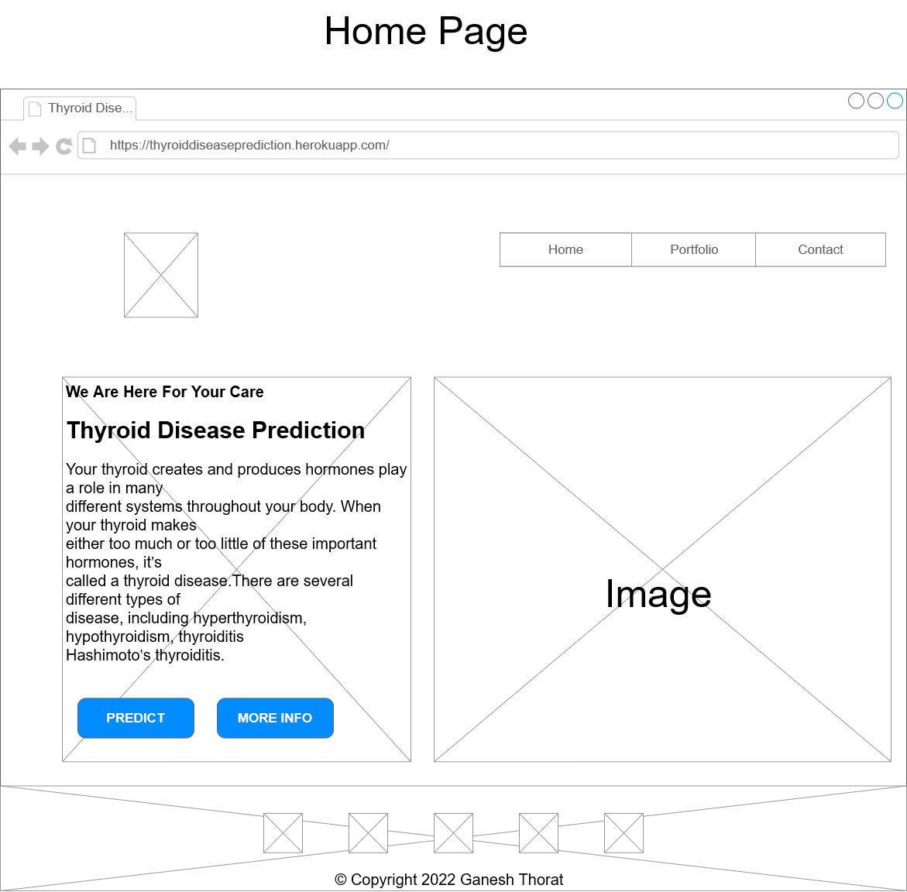

**Prediction Page:**

On this page there will be form for patient to predict Thyroid. User have to fill all the details and have to click on predict button. Below is the image which shows how form will look like:

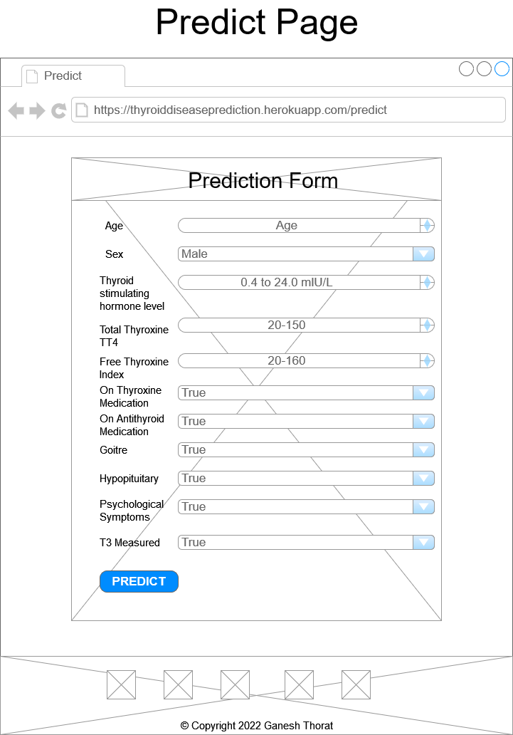

**Result Page:**

After user will give inputs there will be predict button, on clicking predict button the next page will open which will be the result page where the prediction will be shown. Below is the image how the result page will look like:

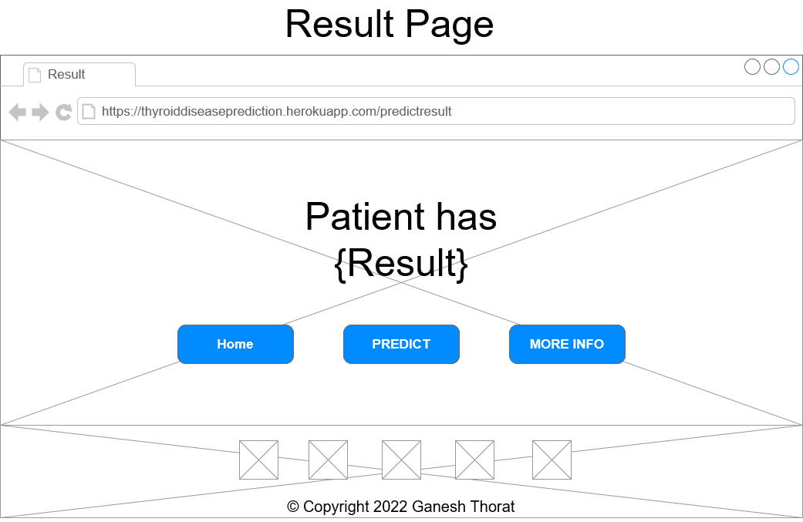

**More info Page:**

After clicking on more info button on home page or result page the user will get redirected to more info page which will shows the information of thyroid disease and how it can be cure.

